

root@cyberster:~$ whoami
> hanzallah — soc_intern
DAY
43-44
Disk Imaging & Hash Verification
// candidate Hanzallah
// program Cyberster — Cybersecurity Internship (Batch 2)
// tutor Abdullah Zia
[ STATUS: TASKS COMPLETE — READY FOR REVIEW ]
// 43-44 OVERVIEW & SCOPE
A physical USB drive was acquired as a forensic image (E01 format) using FTK Imager 8.3.0.27, with write-blocking applied at the source, hash verification performed during acquisition, and the resulting image mounted read-only with Arsenal Image Mounter for browsability validation. This report documents the full process, the hash results, a mount issue encountered and resolved, and one deviation from the original scope (SHA-256 was not captured during acquisition).

// 01 WRITE-BLOCKING METHOD

$ Method applied
Software write-blocking was applied via the Windows registry, setting the system-wide StorageDevicePolicies write-protect flag before the source USB drive was connected:
reg add "HKLM\SYSTEM\CurrentControlSet\Control\StorageDevicePolicies" /v WriteProtect /t REG_DWORD /d 1 /f
This same command was recorded in the FTK Imager acquisition metadata (Notes field) as part of the embedded chain of custody information.
$ Limitation
No hardware write blocker was available for this exercise. Write protection relied solely on the OS-level registry policy (software control), applied and confirmed active before the source drive was connected.

// 02 IMAGE ACQUISITION — FTK IMAGER

$ Acquisition metadata
Tool | Exterro FTK Imager 8.3.0.27
Case number | 007
Evidence number | 01
Unique description | Flash Drive Forensic
Examiner | Hanzallah
Notes | Registry WriteProtect command (see Section 01)
Source | \\.\PHYSICALDRIVE2 — VendorCo ProductCode USB Device
Source size | 60,000 MB (122,880,000 sectors × 512 bytes)
Output format | E01, 39 segments, 1500 MB fragment size, compression level 6
Destination | D:\BACKUP\Flash Forensic\USB007.E01 – .E39

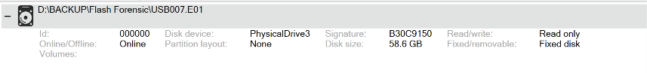
Fig. 1 — Arsenal Image Mounter confirming the mounted image as read-only, fixed disk (initial mount attempt)
Note: the screenshot above is referenced later in Section 04; acquisition-stage screenshots (Create Image / destination configuration) were reviewed live during the session and are represented here via the FTK Imager summary report reproduced in Section 03.

// 03 HASH VERIFICATION

FTK Imager computes a hash of the source before imaging and a hash of the completed image after imaging, then compares them; both must match for the image to be considered a forensically sound copy. The full acquisition summary report generated by FTK Imager is reproduced below as the primary integrity record:
Case Number: 007 | Evidence Number: 01 | Examiner: Hanzallah
Description: Flash Drive Forensic

Acquisition started: 2026-09-14 07:24:10 (local)
Acquisition finished: 2026-09-14 08:23:31 (local) [~59m 21s]

[Computed Hashes — source]
MD5: a2e7111434b459a9eec6b668ebecffbe
SHA1: b485767d15b8cddca76f8b48459100b44c7cd383

Verification started: 2026-09-14 08:23:31 (local)
Verification finished: 2026-09-14 08:28:37 (local) [~5m 6s]
MD5 - Computed / Stored / Report hash: MATCH — verified
SHA1 - Computed / Stored / Report hash: MATCH — verified

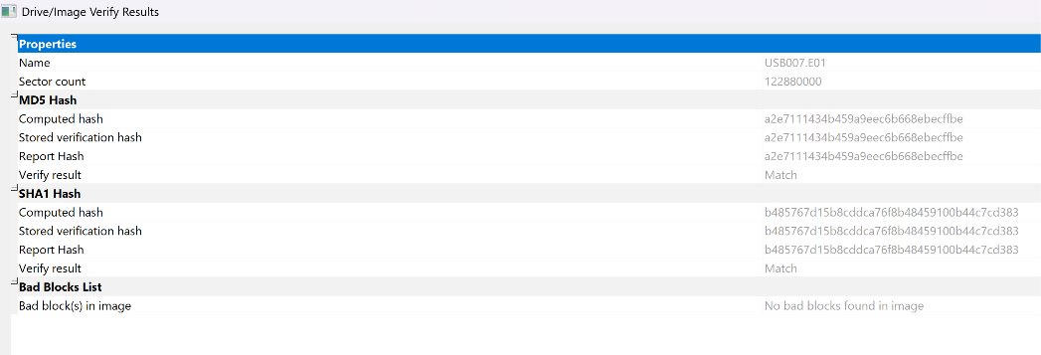

MD5 (source & image) | a2e7111434b459a9eec6b668ebecffbe — VERIFIED
SHA1 (source & image) | b485767d15b8cddca76f8b48459100b44c7cd383 — VERIFIED
SHA-256 | Not captured during acquisition (see limitation below)

$ Deviation — SHA-256 not enabled
The SHA-256 checkbox was not enabled prior to starting acquisition; FTK Imager computed MD5 and SHA1 only. Both algorithms fully verified across computed, stored, and report hash — the image is forensically sound — but the deliverable as originally scoped called for MD5 + SHA-256 specifically.
$ Attempted independent SHA-256 cross-check
Two approaches were attempted post-acquisition to obtain a SHA-256 value without repeating the full ~1 hour acquisition:
- certutil -hashfile against the completed .E01 file directly — produced a value (MD5: 102611b434a335c9621e2c4999901758), but this is NOT comparable to FTK Imager's hash: certutil hashes the raw E01 container file (headers, chunk tables, per-chunk CRCs), not the reconstructed logical bitstream FTK Imager hashes. The mismatch against the FTK-reported MD5 is expected and does not indicate any problem with the image.
- certutil -hashfile against the raw device path (\\.\PhysicalDrive2) — failed with error 0x80070002 (ERROR_FILE_NOT_FOUND) for both MD5 and SHA256; certutil does not reliably support raw physical device paths as input.
Recommendation for future work: use FTK Imager's own Verify Drive/Image function against the physical source with both MD5 and SHA-256 enabled, rather than a generic file-hashing utility, since only a tool that reads the raw device/EWF structure directly produces a hash comparable to the original acquisition hash.

// 04 MOUNTING & VALIDATION

$ Initial mount — partition table not recognized
The completed image was first mounted via Arsenal Image Mounter as a Fixed Disk, read-only. Arsenal Image Mounter reported the mount as PhysicalDrive3, 58.6 GB, Read Only — correct at the mount-tool level:
Fig. 2 — Arsenal Image Mounter: image mounted as PhysicalDrive3, 58.6 GB, read-only

However, Windows Disk Management showed the same disk as Unknown / Not Initialized / Unallocated, with no readable partitions:

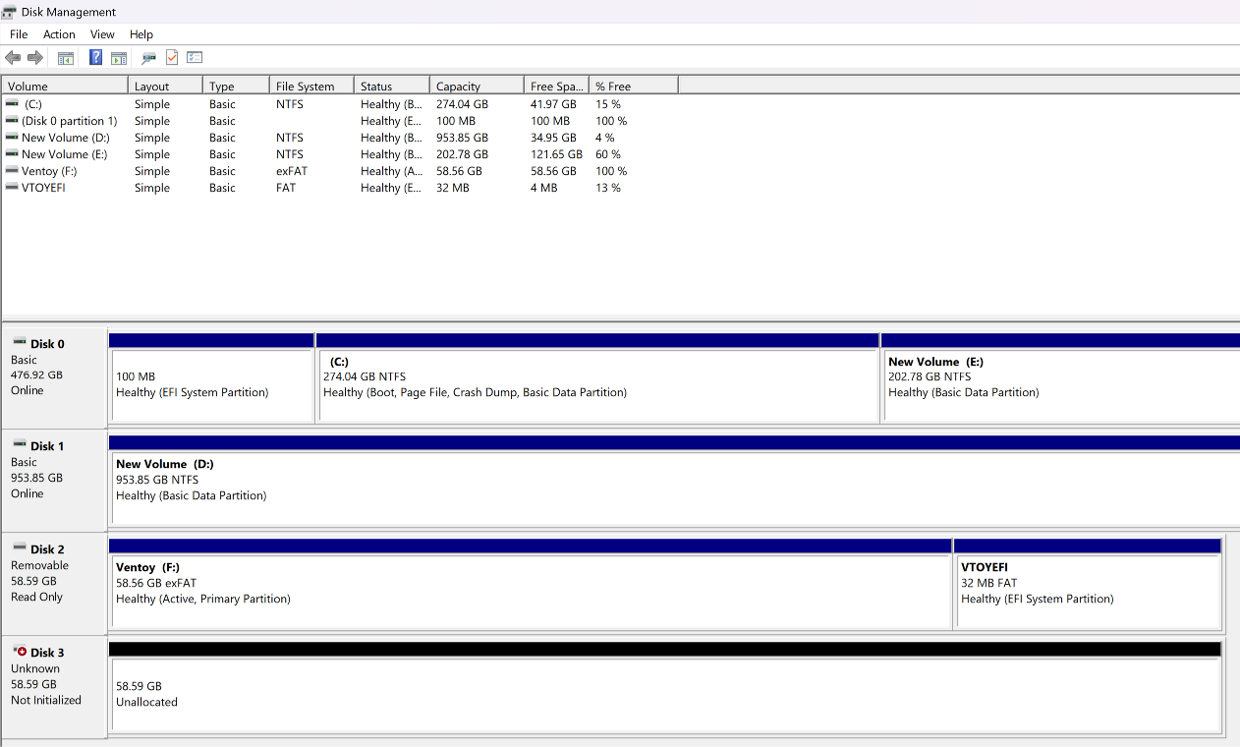
Fig. 3 — Disk Management: Disk 3 (mounted image) shown as Unknown/Not Initialized; Disk 2 (source USB) correctly shown Read Only

A Rescan Disks action was tried as a first troubleshooting step, but this caused Windows to drop the mount from view entirely rather than fix it:
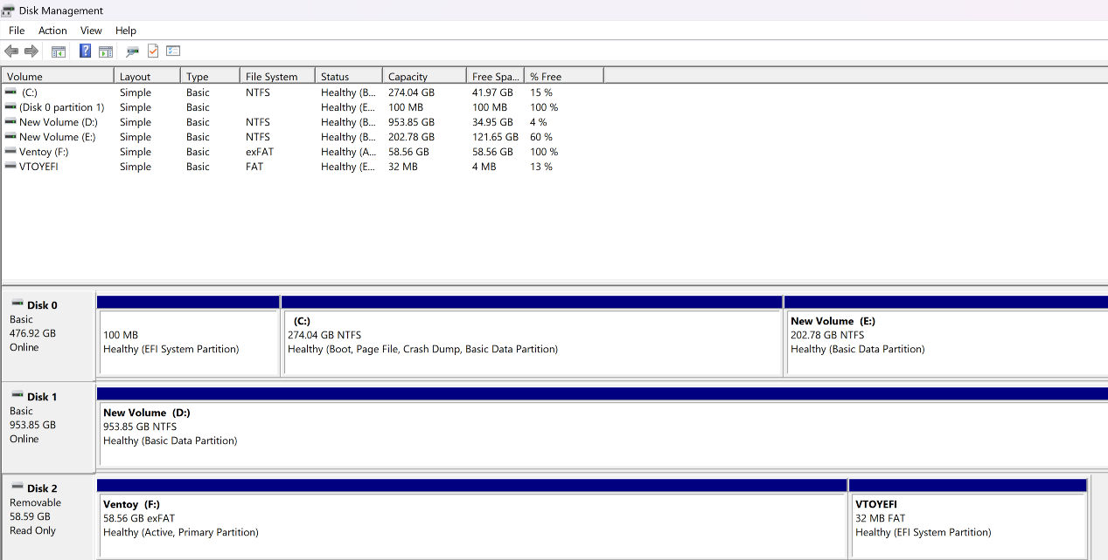
Fig. 4 — Disk Management after Rescan Disks: Disk 3 no longer listed
$ Resolution
The image was unmounted and remounted in Arsenal Image Mounter with the device type set to Removable Disk instead of Fixed Disk — the correct type for a USB-originated image. This resolved the partition table recognition issue immediately:
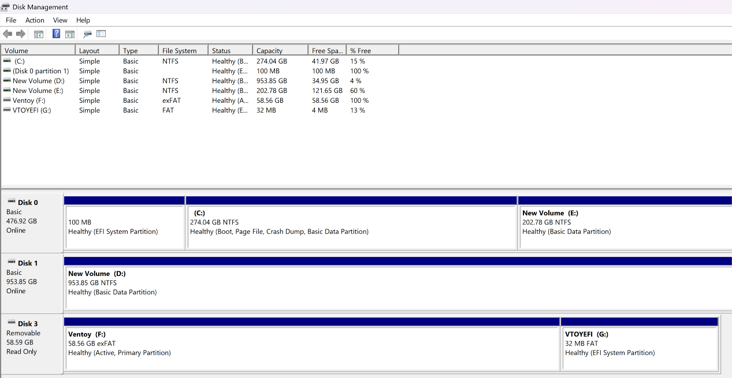
Fig. 5 — Disk Management after remount as Removable Disk: Disk 3 now shows two healthy, Read Only partitions — Ventoy (F:) and VTOYEFI (G:)
Root cause: Arsenal Image Mounter's device-type setting affects how Windows' disk stack interprets the mounted image's MBR/partition table. A USB-originated image mounted as a Fixed Disk was not parsed correctly; mounting as Removable Disk matched the source device's actual type and allowed Windows to read the partition table normally.

// 05 READ-ONLY INTEGRITY TEST

With both partitions visible and browsable, a write attempt was made against the mounted volume to confirm read-only enforcement at the OS level (not merely a UI label):
F:\>echo test > F:\writetest.txt
The media is write protected.
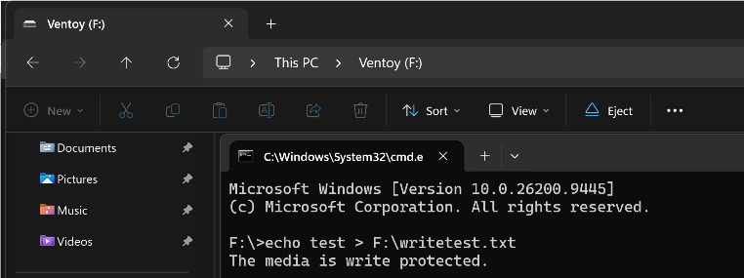
Fig. 6 — Windows Explorer showing the mounted Ventoy (F:) volume with intact folder structure, alongside a refused write attempt ("The media is write protected.")
This confirms two things simultaneously: the image mounted successfully with its original file/folder structure intact and browsable, and the read-only mount is enforced by the OS, not just displayed as a status label.

// 06 CHAIN OF CUSTODY

Evidence item / ID | Case 007, Evidence 01 — "Flash Drive Forensic" (USB device, ~60 GB / 58.6 GiB)
Acquisition start | 2026-09-14 07:24:10 (local)
Acquisition finish | 2026-09-14 08:23:31 (local)
Verification window | 2026-09-14 08:23:31 – 08:28:37 (local)
Examiner | Hanzallah
Forensic workstation | DESKTOP-6939QPJ — Windows 11 Pro, Intel Core i7-8850H, 32 GB RAM
Source device | VendorCo ProductCode USB Device, Serial 9961501060430223872, Interface: USB
Write-blocking method | Software — Windows registry StorageDevicePolicies\WriteProtect=1 (no hardware write blocker available)
MD5 (source & image) | a2e7111434b459a9eec6b668ebecffbe — verified
SHA1 (source & image) | b485767d15b8cddca76f8b48459100b44c7cd383 — verified
SHA-256 | Not captured — see Section 03 limitation and recommendation
Image storage location | D:\BACKUP\Flash Forensic\USB007.E01 – .E39 (39 segments)
Date signed | 14-09-2026

// 07 FINDINGS & LIMITATIONS

- SHA-256 was not enabled during acquisition; only MD5 and SHA1 were computed and verified. Both fully matched across computed/stored/report hash, so the image itself is forensically sound, but the MD5+SHA-256 deliverable requirement was not fully met.
- Generic file-hashing tools (certutil) cannot substitute for format-aware hashing: hashing an .E01 file directly hashes the EWF container, not the logical bitstream, and certutil does not support raw physical device paths as input.
- Mount device-type selection matters for USB-originated images: mounting as Fixed Disk caused Windows to fail to parse the partition table; mounting as Removable Disk (matching the source's actual type) resolved it without any change to the image file itself.
- A Disk Management "Rescan Disks" action can cause an unrecognized mounted disk to disappear from view rather than re-parse it — remounting via the mounting tool, not just rescanning in Windows, was the effective fix.

// 08 DELIVERABLES CHECKLIST

- Acquisition report — this document
- Chain of custody documentation — Section 06 (pending signature)
- Hash verification record — Section 03 (FTK Imager summary report reproduced in full)
- Mounted image screenshots — Figs. 2–6, showing the mount issue, resolution, and final read-only browsable state

